**Tutorial – 13: Transaction Processing & Concurrency Control**

1. List all possible schedules for transactions T1 and T2 from below figure and determine which are conflict serializable (correct) and which are not.

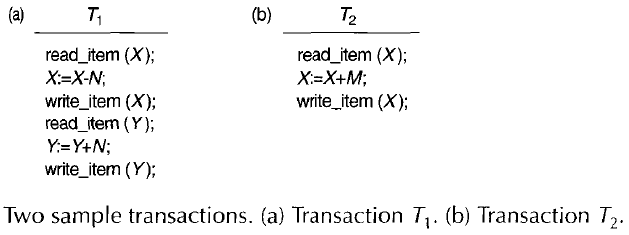

2) Check whether the given schedule S is view serializable or not. If yes, then give the serial schedule.

**S : R1(A) , W2(A) , R3(A) , W1(A) , W3(A)**